Subject: DF & IR

Bandit From overthewire.org

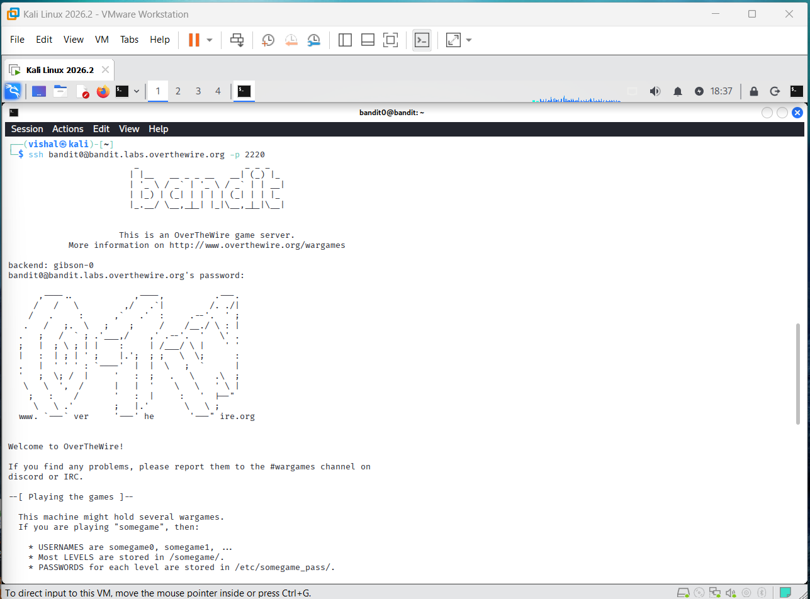
connected to the OverTheWire Bandit server using SSH from Kali Linux. used the Bandit username and port 2220 to connect to the server. After entering the password, I successfully logged in to the Bandit game environment.

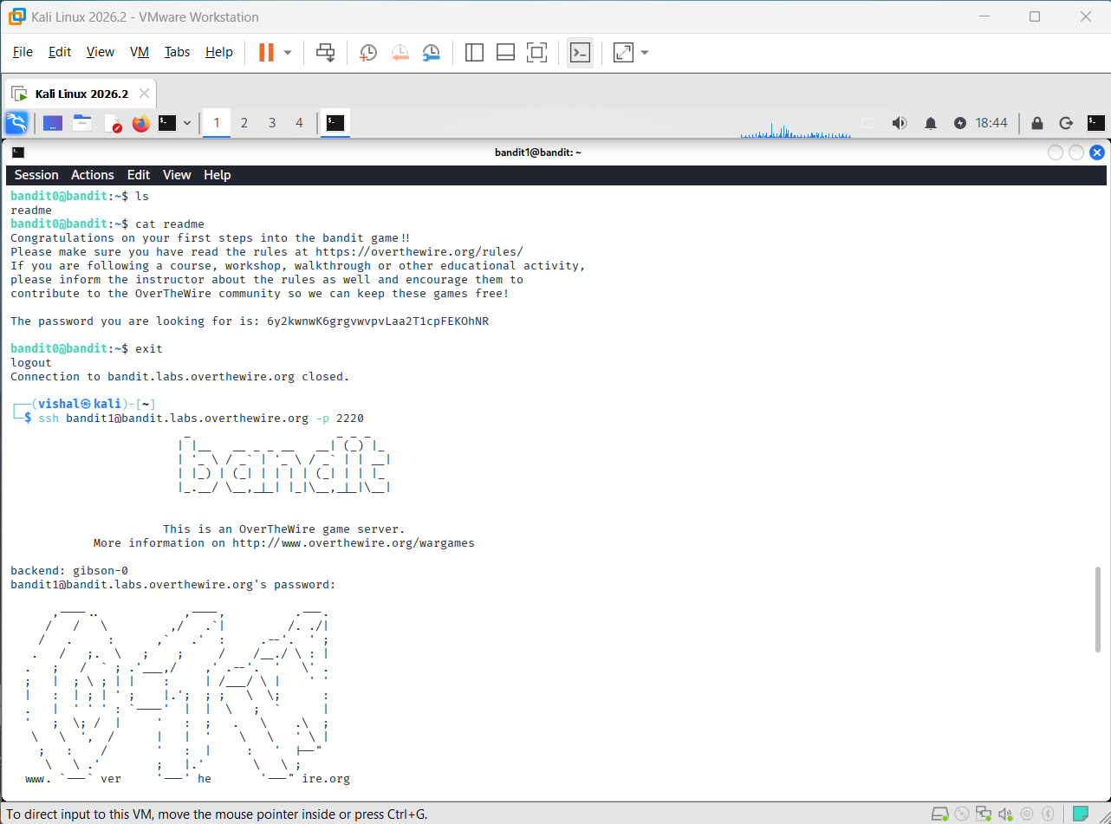
used the ls command to check the files in the current directory.
readme file was available, so I used the cat readme command to display its contents.
file contained the password required to move from Bandit Level 0 to Level 1.

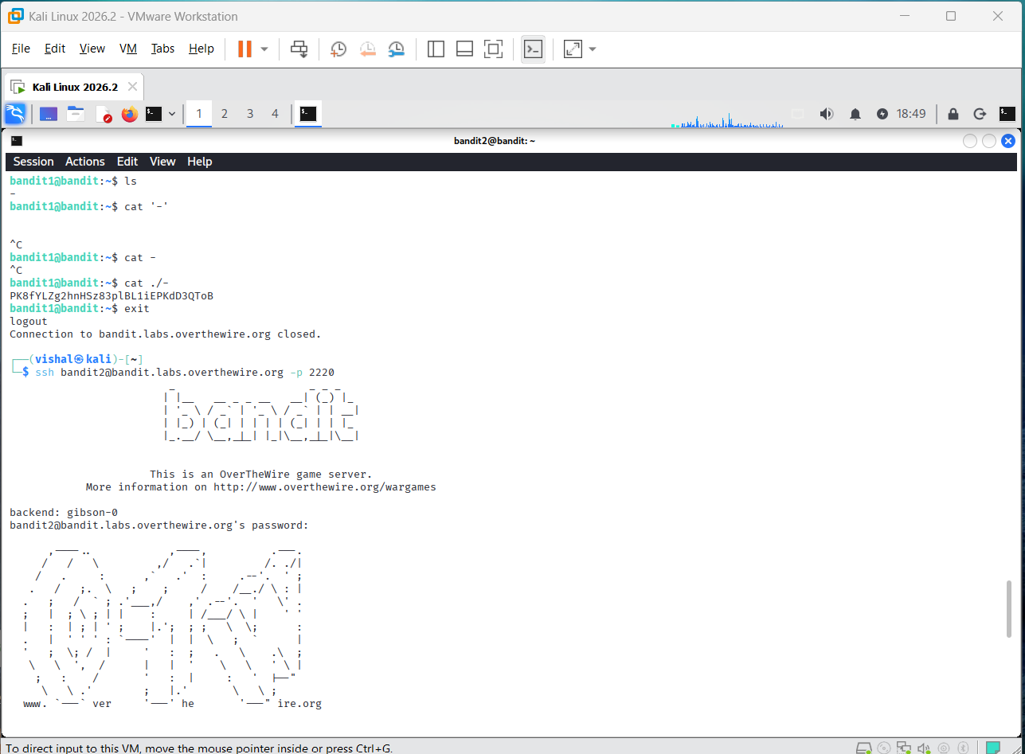
password was stored in a file whose name was -.
first tried using cat -, but it did not read the file as expected.
then used cat ./- to specify the file path correctly and obtained the password for the next level.

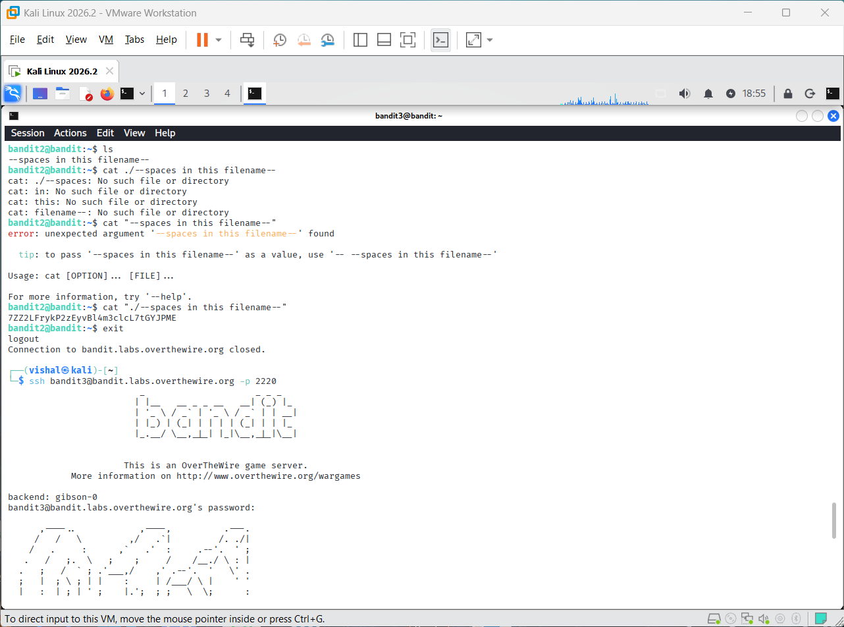
entered the inhere directory and used ls -a to display the hidden file.
file name contained spaces, so directly using cat caused errors.
used the correct path with quotes, cat "./--spaces in this filename--", to read the file and obtain the password.

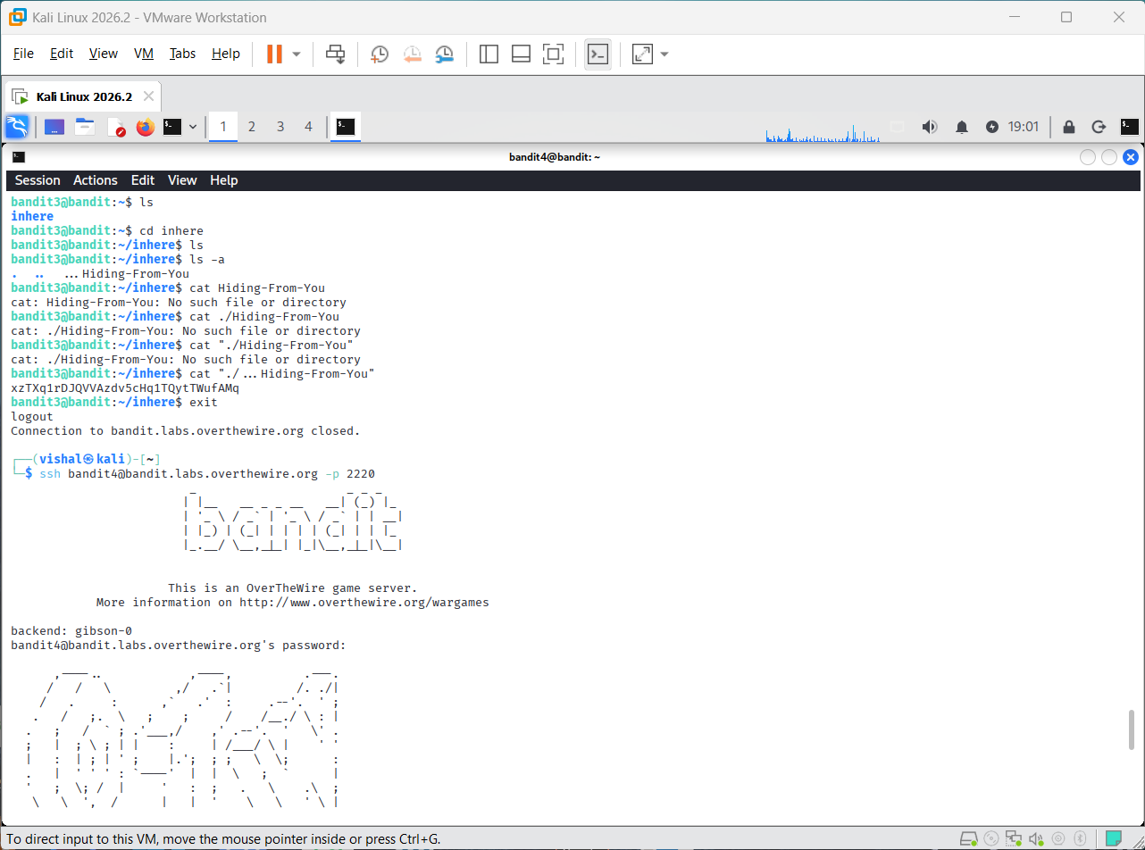
entered the inhere directory and used ls to view the available files.
files had names beginning with a dash, so I tried reading them using their paths.
readable file contained the password needed to continue to the next Bandit level.

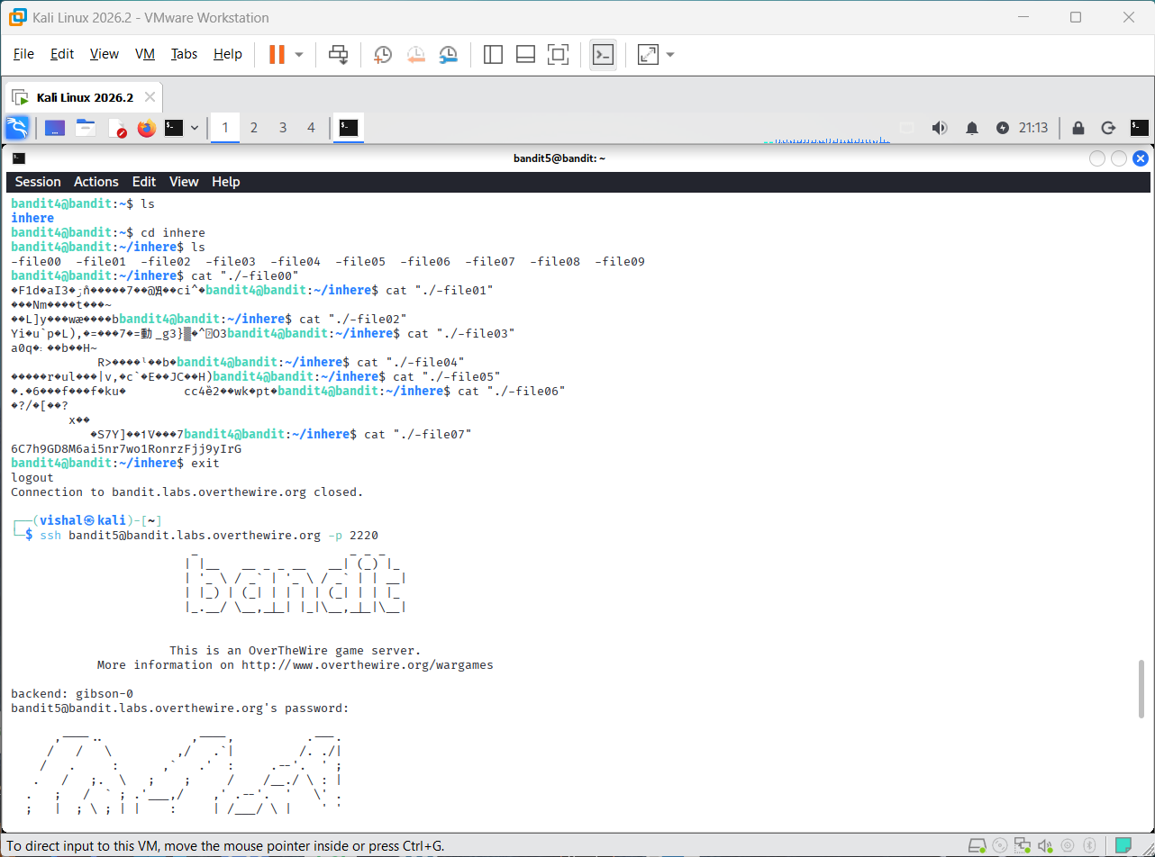
I am checked the files inside the inhere directory using the cat command.
Most of the files contained unreadable or random characters.
The correct file displayed readable text containing the password for the next level.

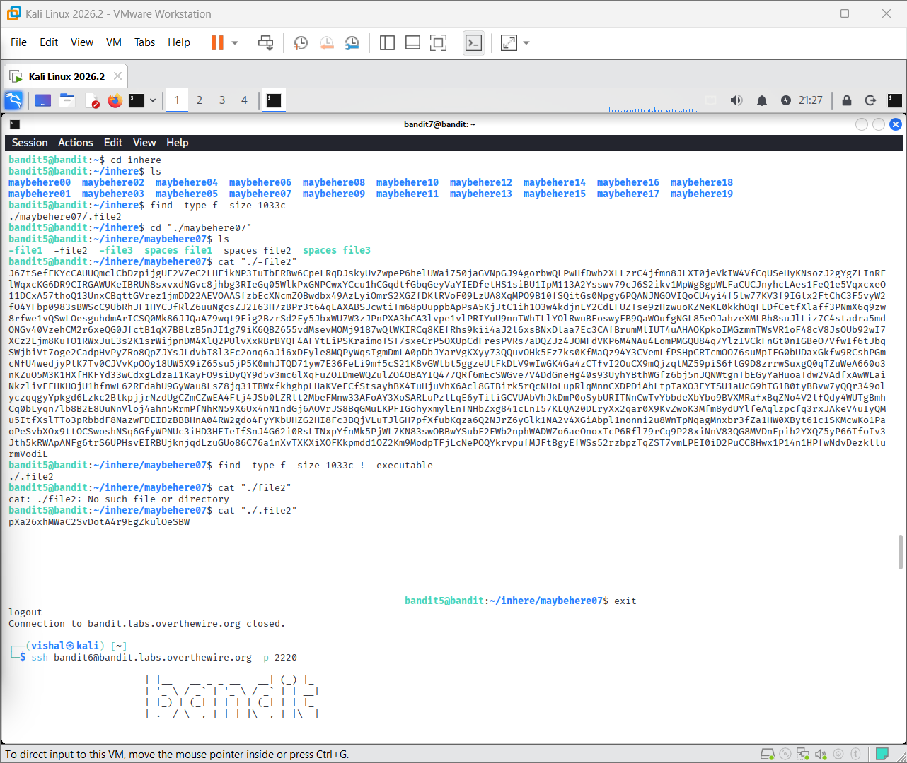
I am used the find command to search for a file with a size of 1033 bytes.
The search showed the file ./file2, and I then checked the file that was not executable.
Using cat "./file2" displayed the password for the next Bandit level.

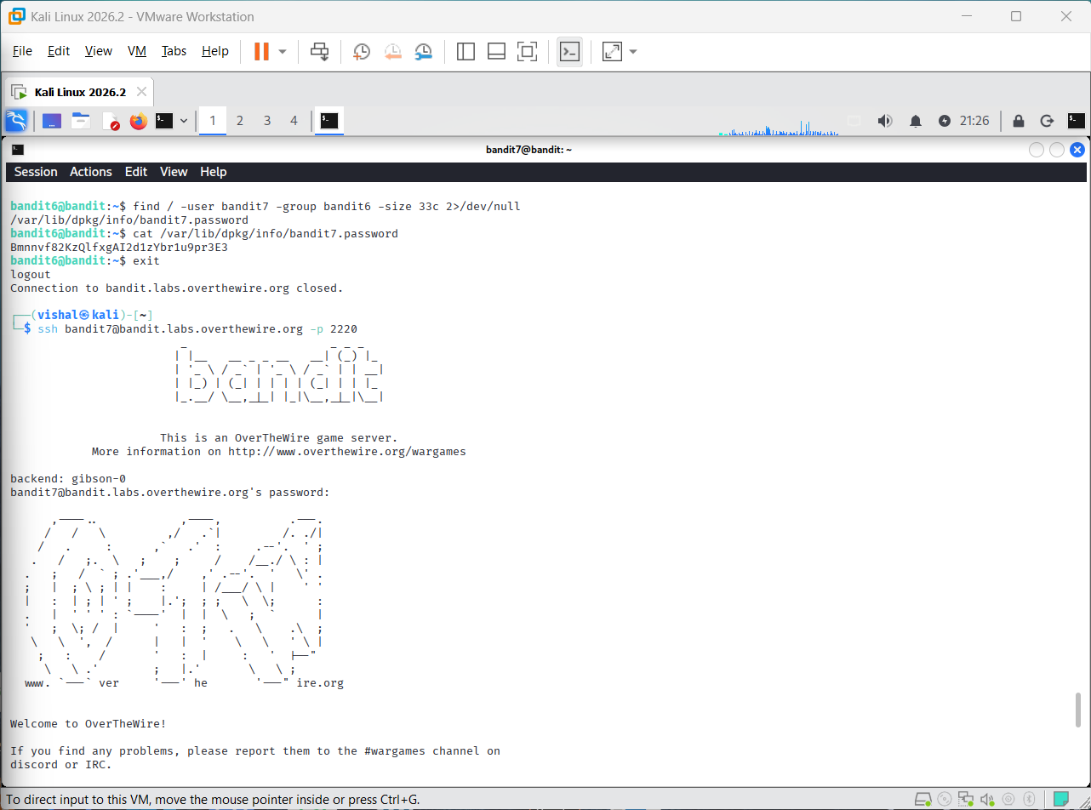
I am used the find command to search for a file owned by bandit7, belonging to group bandit6, and having a size of 33 bytes. The command located /var/lib/dpkg/info/bandit7.password.
I used the cat command to read the file and obtained the password for Bandit Level 7.

